**SEPM**

**Experiment 11**

# Aim

To provision a LAMP/MEAN Stack using Puppet Manifest.

# Theory

The widely popular LAMP stack is a set of open-source software used for web application development.

For a web application to work smoothly, it has to include an operating system, a web server, a database, and a programming language. The name LAMP is an acronym of the following programs:

Linux Operating System

Apache HTTP Server

MySQL database management system

PHP programming language

A LAMP stack is a bundle of four different software technologies that developers use to build websites and web applications. LAMP is an acronym for the operating system, Linux; the web server, Apache; the database server, MySQL; and the programming language, PHP. All four of these technologies are open source, which means they are community maintained and freely available for anyone to use. Developers use LAMP stacks to create, host, and maintain web content. It is a popular solution that powers many of the websites you commonly use today.

In the LAMP stack, the P can also refer to two other programming languages – Perl or Python. All three are simple, yet useful, dynamic tools for creating environments in which you can successfully develop applications. Nowadays, there is a wide variety of scripting languages to choose from, including JavaScript, Ruby, and many more.

Importance

Web developers choose a LAMP stack to build web applications for the following reasons.

### Cost

All LAMP technologies are open source, which means that any developer or company can use them without having to pay licensing fees. Instead of purchasing proprietary stack components, you can download the operating system, web server, database, and scripting language for free. This lowers the cost of building web applications.

### Efficiency

Setting up a new web development stack requires rigorous testing of different frameworks, modules, libraries, and tools. On the other hand, a LAMP stack is a tried-and-tested web development solution. Web developers can prioritize and speed up application development to focus on what they are building instead of how they are building it.

### Maintenance

Software experts from around the globe contribute to the development of LAMP stack technologies by changing, commenting on, and reviewing the publicly available source codes. They regularly maintain and update the technologies so that they remain relevant and secure.

### Support

Popular open-source technologies, such as LAMP stacks, have the support of a large, global IT community. Hence, LAMP stack users can more easily find information on public IT forums. Web developers can refer to example codes or use tested plugins created by the open-source community.

### Flexibility

A LAMP stack gives both reliability and flexibility to web developers. While the LAMP architecture specifies the software components for each layer, developers can replace them as they see fit. For example, they can use another operating system besides Linux as the stack foundation.

Working:

Web applications use a LAMP stack to respond to requests from web browsers. The Apache web server and MySQL database run on the Linux operating system and communicate using PHP. When you open a webpage in a browser, the LAMP stack goes through the following process.

### Receives requests

### Processes requests

### Returns responses

# Implementation

You’d need your Puppet cluster running to perform these commands.

Steps:

1. To test your cluster setup, run this command -

*sudo /opt/puppetlabs/bin/puppet agent --test*

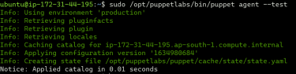

If the output is normal, you can proceed.

2. Change directories to the production folder

*cd /etc/puppetlabs/code/environments/production/manifests*

3. Use nano to create a new lamp.pp file.

*sudo nano lamp.pp*

4. Add this code to the file which will install all necessary dependencies and provision the stack. You can obtain this code from here.

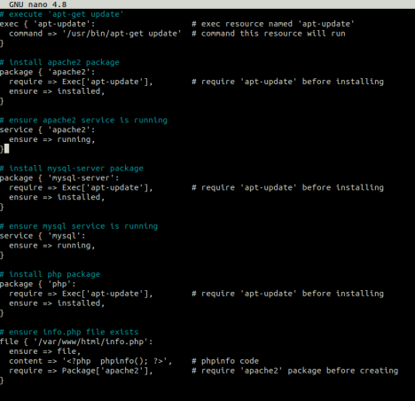

5. Change directory to the bin folder of puppetlabs where the puppet executable is present. Cd

*/opt/puppetlabs/bin*

6. Use puppet apply to apply the scripts.

*./puppet apply*

*/etc/puppetlabs/code/environments/production/manifests/lamp.pp*

**

7. Once done, go back to the EC2 Console, copy the public IP address of the client machine and put it in the browser.

*The URL is - http://ip_address_of_your_client/info.php*

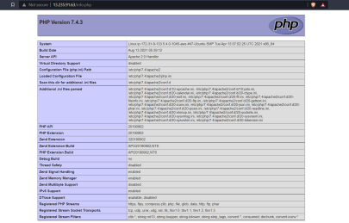This verifies the provision of a LAMP stack using Puppet.